**HTML5 P**

**roject – Rockford University**

**Problem Statement**

Rockford University proposes to revamp their existing web site. The University intends to have a HTML5 complaint website that is informative and simple to navigate. To this end the website scheme and layout needing to be developed should resemble the below depicted view.

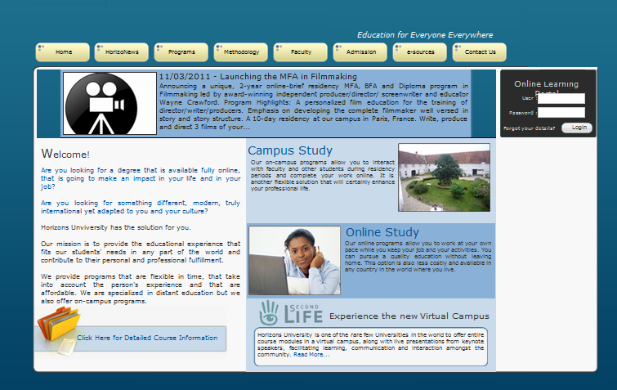

The navigation bar should contain the following links that lead to relevant pages

1. Home
2. Newsletter
3. Programs / Courses
4. Faculty
5. Admission / Registration
6. Contact Us

[Note : Use CSS styles for <div> tags to display the blocks constituting the links in the navigation bar.]

**Navigation Details**

***Newsletter*** – Displays the monthly newsletter published by the University.

***Programs*** – Lists the various courses offered by the University categorised into Campus and Online programs. The start date for each course needs to be shown.

[Note : Use HTML5 Canvas to present the course description and an image alongside each course depicting the course. (For example an image of a computer representing a course in IT, an image of a scroll representing a course in law)]

The course fee for each course should be displayed.

[Note : Use <div> with relevant positioning to display the fee adjacent to each course detail shown]

This page should also provide a dropdown to allow users to select a currency. On the basis of the currency selected the course fee gets updated accordingly.

[Note : Use Web Workers to accomplish this task.]

***Faculty*** – Shows thumbnails of a few prominent faculties of the University. Each thumbnail when clicked upon displays the faculty’s qualification and experience at a designated location on the page.

[Note : Use <div> tags with relevant styling to display faculty details]

***Admission*** – Displays a registration form for prospective students to register for a course.

[Note: Use HTML5 form elements with appropriate characteristics such as “Placeholder” etc]

Once a student registers, persist the Student name and personalize the web site by displaying “Welcome <StudentName>” on each of the pages.

[Note : Use localStorage to implement this functionality.]

***Contact Us*** – Displays a page providing contact details of the University. This page also puts up a Google map snapshot with a pin depicting the location of the University

[Note : Use Geolocation API with Google Maps API to accomplish the task]